Laser Safety Rules
Class 1 Lasers
- A warning sign indicating the laser classification should be placed in a visible location on the laser.
Class 2 Lasers
- Do not stare at the laser or permit any person to stare at the laser beam.
- Do not point the laser at a person's eye.
Class 3 Lasers
- Never aim a laser beam at a person's eye.
- Use proper safety eyewear if there is a chance that the beam or hazardous specular reflection will expose the eyes.
- Only experienced personnel should be permitted to operate the laser. Never leave an operable laser unattended if there is a chance that an unauthorized person may attempt to use it. A key switch should be used. A warning light or buzzer should indicate when the laser is operating.
- Enclose as much of the beam path as possible.
- Avoid placing the unprotected eye along or near the beam axis as attempted in some alignment procedures since the chance of hazardous specular reflection is greatest in this area.
- Terminate the primary and secondary beams if possible at the end of their useful paths.
- Use beam shutters and output filters to reduce the beam power to less hazardous levels when the full output power is not required.
- Make sure that any spectators are not potentially exposed to a hazardous condition.
- Attempt to keep laser beam paths above or below either sitting or standing position eye level.
- Operate the laser only in a well-controlled area. That is, in a closed room with no windows and controlled access.
- Label lasers with appropriate Class III danger statements and placard hazardous areas with danger signs.
- Mount the laser on a firm support to assure that the beam travels along the intended path.
- Assure that individuals do not look directly into a laser beam with optical instruments unless a adequate protective filter is present.
- Eliminate unnecessary specular (mirror-like) surfaces from the vicinity of the laser beam path.
Class 4 Lasers
- Enclose the entire laser beam path if at all possible. If this is done, the laser device could be considered to be a less hazardous classification.
- Confine indoor laser operation to a light-tight room with interlocked entrances to assure that the laser cannot emit when a door is open.
- Insure that all personnel wear adequate eye protection, and if the laser beam irradiance represents a serious skin or fire hazard that a suitable shield is present between the laser beam and the any persons in the room.
- Use remote firing and video monitoring or remote viewing through a laser safety shield where feasible.
- Use beam traverse and elevation stops on outdoor laser devices to assure that the beam cannot intercept occupied areas or intercept aircraft.
- Use beam shutters and laser output filters to reduce the laser beam irradiance to less hazardous levels whenever the full beam power is not required.
- Assure that the laser device has a key-switch master interlock to permit only authorized personnel to operate the laser.
- Install appropriate signs and labels on entrances, switches and anywhere an unauthorized person might mistakenly activate the laser.
- Remember that optical pump systems may be hazardous to view and that once optical pumping systems for pulsed lasers are charged, they can spontaneously discharged, causing the laser to fire unexpectedly.
- Use dark, absorbing diffuse, fire-resistant targets and backstops where feasible.

 | Fun With Lasers  http://felesmagus.com/pages/lasers-safety.html
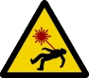 | Laser Safety  Safety might seem like a boring and tiresome topic, and really most of it is little more than common sense. But common sense is not always as common as it ought to be, and sometimes we can get a little carried away with the fun stuff, that we forget what's important. So, until replacement eyeballs are cheap and effective, let's take some time to think about laser safety.  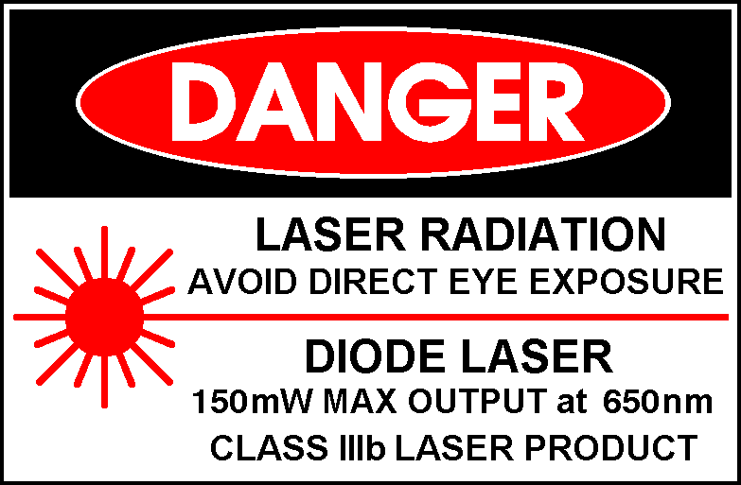  Class 3b: For Laser product with 150 mW Max output at 650 nm  General Laser Safety  Safety guidelines that apply to lasers of all power classes  - Never, under any circumstances, look into the beam of any laser! I don't care if you have safety glasses, or if it's only a 2mW keychain pointer. Don't do it! For one thing, don't get into a habit of looking into the beam with cheap pointers, you might someday be working with a more powerful laser. Laser Safety goggles protect against accidental exposures, they aren't meant for direct viewing of the beam. There's just so many things wrong with the idea of looking into the laser beam. Don't do it.  - Never, under any circumstances, aim the beam of any laser at another person or animal! See above. It's foolish to risk your own eyeballs, it's criminal to risk someone else's.  - Never, under any circumstances, aim the beam of any laser at a moving vehicle! This is in fact a criminal offense in most parts of the world. It's also idiotic, for the reasons listed above.  - Keep your Laser(s) out of the reach of children! Or, any irresponsible people, in fact. Don't leave your laser where your child, or kid brother, will find it. And don't hand it around at your drunken frat party. You might know all the safety rules, but what are the odds that everyone else does too?  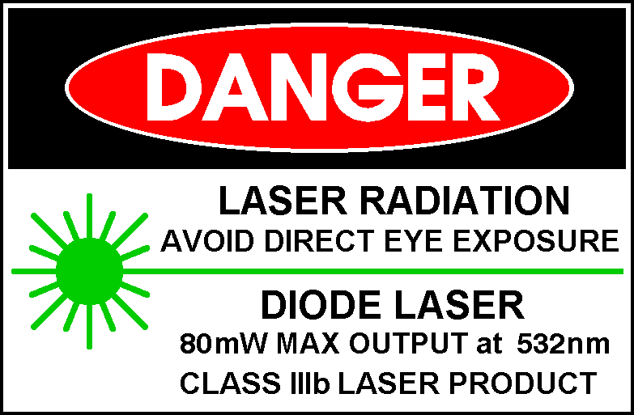  Class 3b Laser Safety  Safety guidelines that apply to class 3b lasers -- in addition to the guidelines mentioned above.  - When using your laser outside, do not aim it at any buildings or areas where people may be. If you aren't sure that an area does not contain any people, then do not aim your laser at it.  - Higher-Powered Lasers are not toys! Lasers above 5mW in power are capable of burning and blinding. They are tools and should never be treated in a careless or irresponsible fashion.  - Laser Safety Goggles are strongly recommended. If you plan on doing tricks such as burning matches or balloons, or melting tape or plastic, or even setting up a lightshow, you should invest in properly rated Laser Safety Glasses. Staring closely at the intense light while doing tricks, or working with mirrors and other reflective surfaces, creates the risk of specular reflections. Safety glasses can help protect your vision from accidental exposure.  - When using your laser indoors, be careful of where the beam is terminated. Higher powered lasers can cause some materials to smoulder. Specular reflections are also possible, from many household surfaces.  About Laser Eye Damage  Lasers above 5mW in power, are increasingly more dangerous to your vision, as the power goes up. At 100mW for instance, a laser can cause damage to your eye faster than you can blink - in only 1/1250th of a second.  Damage, however, does not always mean instantaneous total blindness. You may see a bright flash then your vision returns and you think you have been lucky. Eye damage can be cumulative, and can go undetected until it is too late.  The brain is very good at hiding blind spots. For example, all of us are born with two 10-degree blind spots, one in each eye. We don't notice them because the brain fills in the missing data with what the opposite eye sees - or if you close one eye, the blind spot is filled with what's around it.  So while you may not immediately see black spots, you may find areas of vision become blurry or fuzzy. This kind of damage will accumulate with each 'accident' or 'close call', and does not heal.  About Laser Safety Goggles  Laser Safety Goggles (or Laser Safety Glasses) are more than just pretty coloured plastic. Properly rated Laser Safety Glasses will indicate what wavelength(s) they are designed for, and how much protection they offer (Optical Density, or OD).  Laser Safety Goggles are wavelengh-specific. Goggles that protect your eyes against one wavelength do not necessarily protect against another. For instance, goggles that protect against red lasers (630 to 670nm) usually offer little or no protection at blue and green wavelengths (470-550nm). Multi-line goggles do exist, which protect against multiple wavelengths, but they tend to be much more expensive.  Real Laser Safety Goggles tend to be a bit more expensive than you might expect. This is because they are specially designed to try to meet two conflicting goals: they have to stop the intended wavelength of laser light from passing through, but they also have to let as much of all other wavelengths of light through. Laser Safety Goggles are designed to absorb their intended wavelength rather than reflect it, so as to minimise the possibility of additional stray reflections around.  The companies that sell Laser Safety Goggles test their goggles, some provide certification, and that means you know you can trust your eyesight to them.  Sunglasses, welding glasses, are not good alternatives. They tend to reduce overall light transmission, making everything 'darker' to you. This causes your pupils to dilate so you can see better. Meanwhile, sunglasses and welding goggles may not even absorb well at the particular wavelength of your laser. So they can be doubly-harmful, dialting your pupils while not substantially protecting your eyes.  Laser Safety Goggles can protect and save your eyesight if you should be accidentally exposed to laser radiation. They are never intended for direct viewing of the beam.  